Technical Design Proposal for Telcomsel RFP

- Tencent Cloud
Content
Cloud Metrics 3
1. Solution Introduction 3
2. Required Cloud Services 4
3. Setup Steps 4
4. Capabilities/Limitations 5
IAM, Resource and cost/billing management 5
1. Solution Introduction 5
2. Required Cloud Services 6
3. Setup Steps 7
3.1. IAM & Resources Management 7
3.2. Billing by Tag 10
4. Capabilities/Limitations 11
Tencent Cloud Organization 12
Tencent Cloud Control Center 13

IAM, Resource and cost/billing management

Solution Introduction
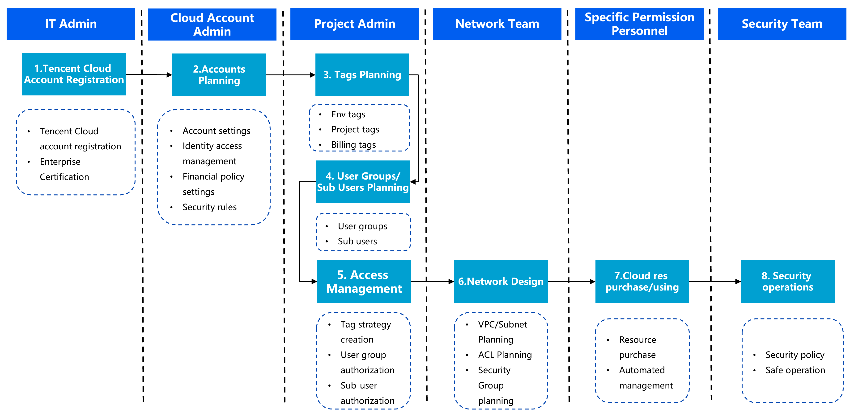
- CAM: Tencent Cloud provides CAM (Cloud Access Management) service help to control cloud resources access and users’ permission. You can use CAM to create sub-users, user groups, and roles and control their access scope through policies.
Together with Tencent Cloud Tag service, Telcomsel can manage your cloud resources and teams in an efficient way.
- For user management: CAM supports Single Sign-On (SSO) that uses SAML 2.0 and OIDC protocols, allowing external users who have authenticated through an Identity Provider (IdP) to directly access your Tencent Cloud resources.
Currently, Tencent Cloud supports two modes of SSO login: user-based SSO and role-based SSO. .
- For billing management: Telcomsel can set the certain tag as a cost allocation tag. Each cost allocation tag is a column in bills, and the values of a tag are displayed in the corresponding rows of the resources they are attached to.

Billing Model:
Tencent Cloud Control Center/CAM/Tags are free to use.

Required Cloud Services
- Tencent Cloud CAM
Cloud Access Management (CAM) is a permission and user management system designed for secure and precise product management and access:
- You can create users and roles in CAM and assign security credentials such as console login passwords and Cloud API keys to them.
- You can also request temporary security credentials to enable access to Tencent Cloud resources.
- You can manage permissions to control what actions users and roles can perform and what resources they can access.
- You do not need to create organizational users' sub-users or collaborators if your organization already has a private network account system, as identity provider (IdP) will provide single sign-on (SSO) for these users and IdP-verified external users can access your Tencent Cloud resources directly.
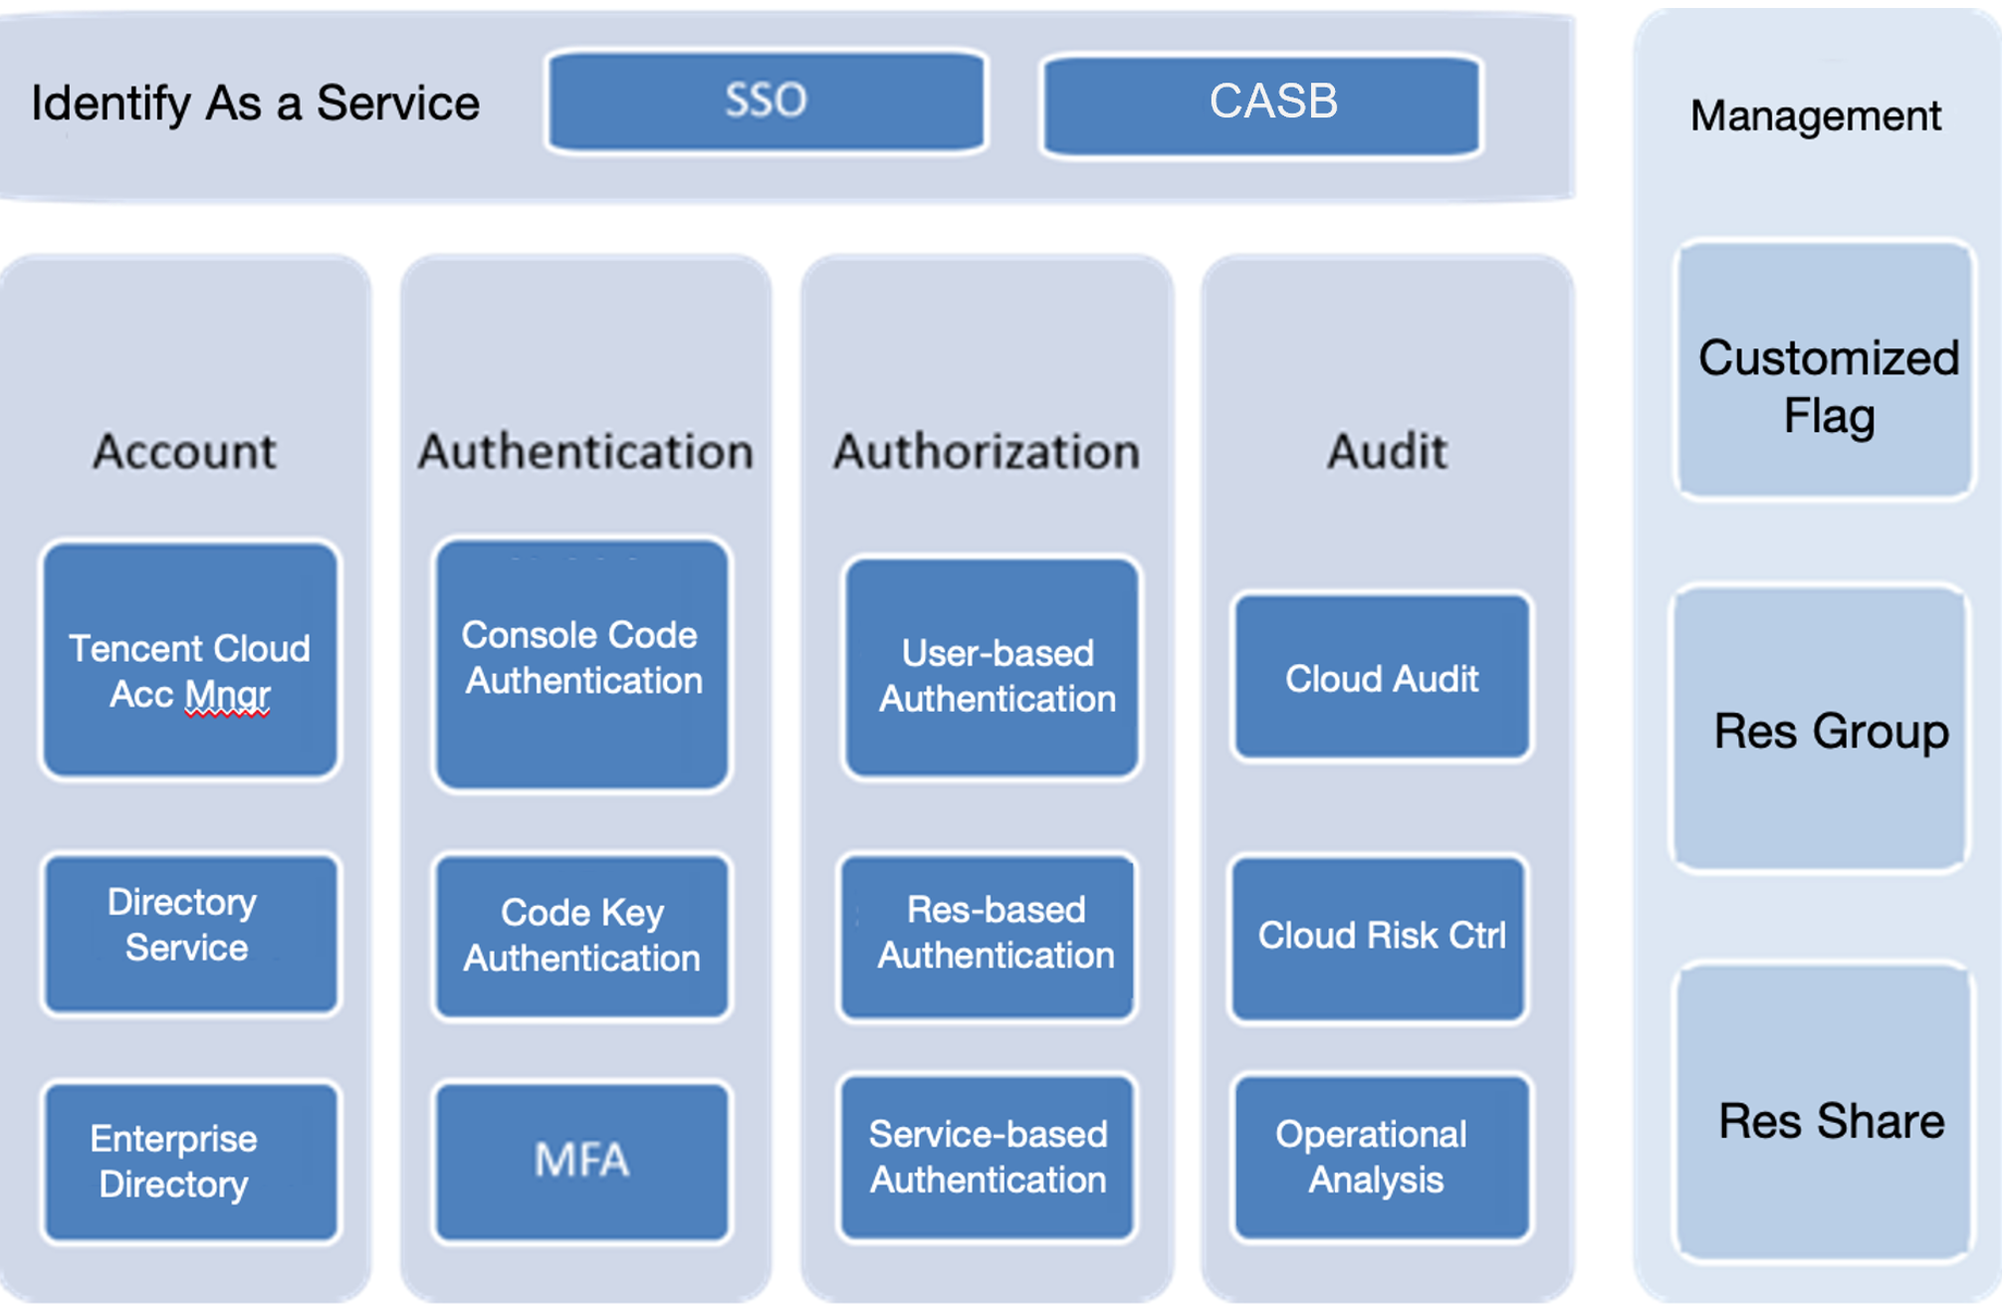

- Tencent Cloud Tag
Tag is a cloud resource management tool that allows you to use different standards to categorize, search for, and aggregate cloud resources having the same attributes.
A tag consists of a tag key and tag value. You can create a tag and bind it to your cloud resources. A tag key can have multiple tag values, and a key-value pair can be bound to multiple resources.
Tags used for bill splitting and cost analysis are called cost allocation tags, which is a collection of resource labels managed by users according to their own requirements.

Setup Steps

3.1. IAM & Resources Management
- Account Planning
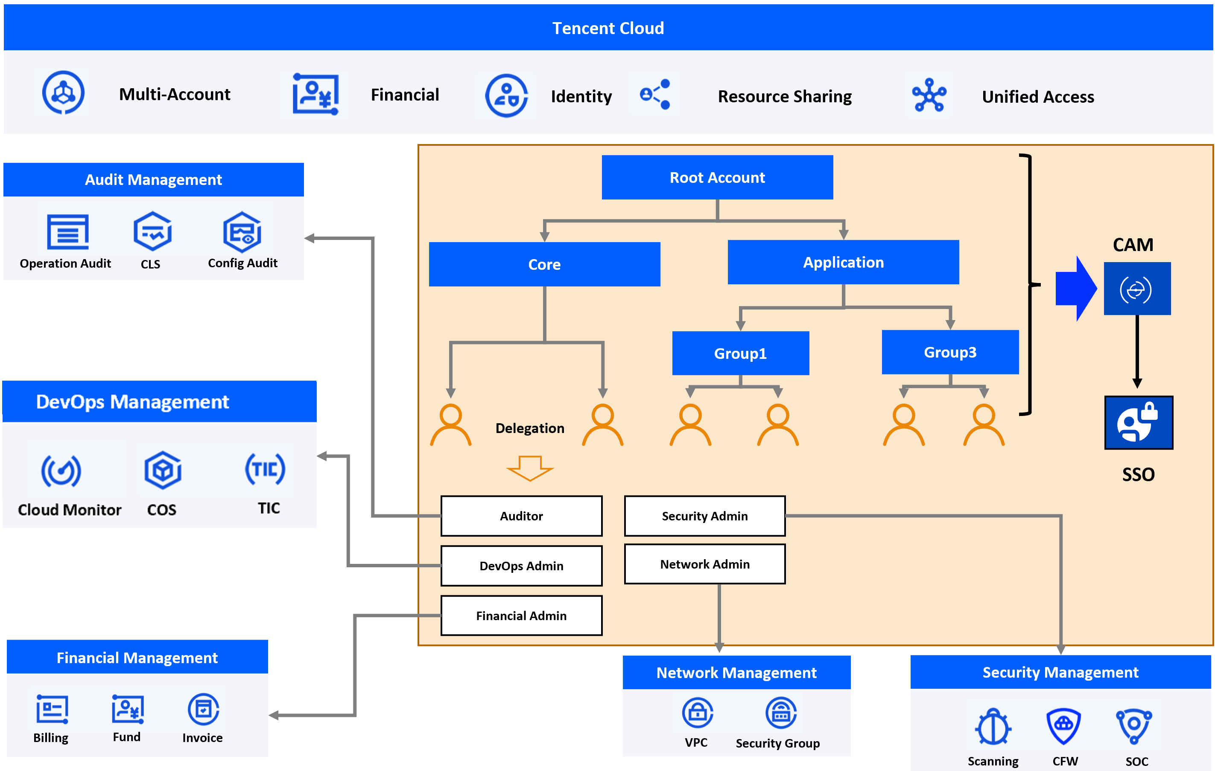
- Grant fine-grained permissions: Account – Role - Resource - Action - Condition
- Secondary identity verification: MFA device verification (divided into hardware MFA device verification and virtual MFA device verification), mobile phone verification code verification
- Federated Identity Management: Security Assertion Markup Language 2.0

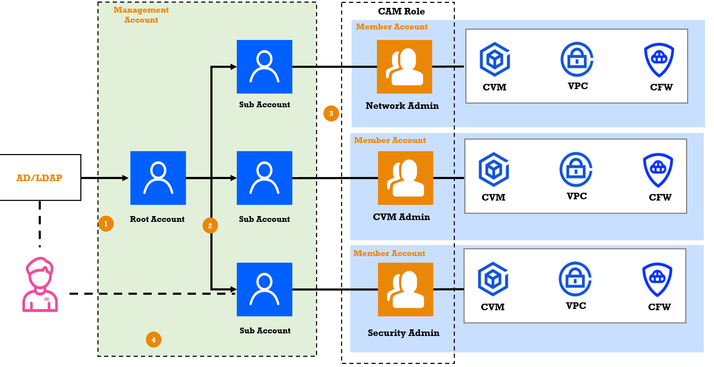
- Tencent cloud CAM supports to act as service provider and integrate with third part identity source like Microsoft AD/GCP IdP.
- Tencent cloud CAM supports sub-accounts based on RBAC or ABAC mode.
- Each role which is defined by customers can be attached to different functional users to meet the min-permission best practices.

- CAM Policy Planning
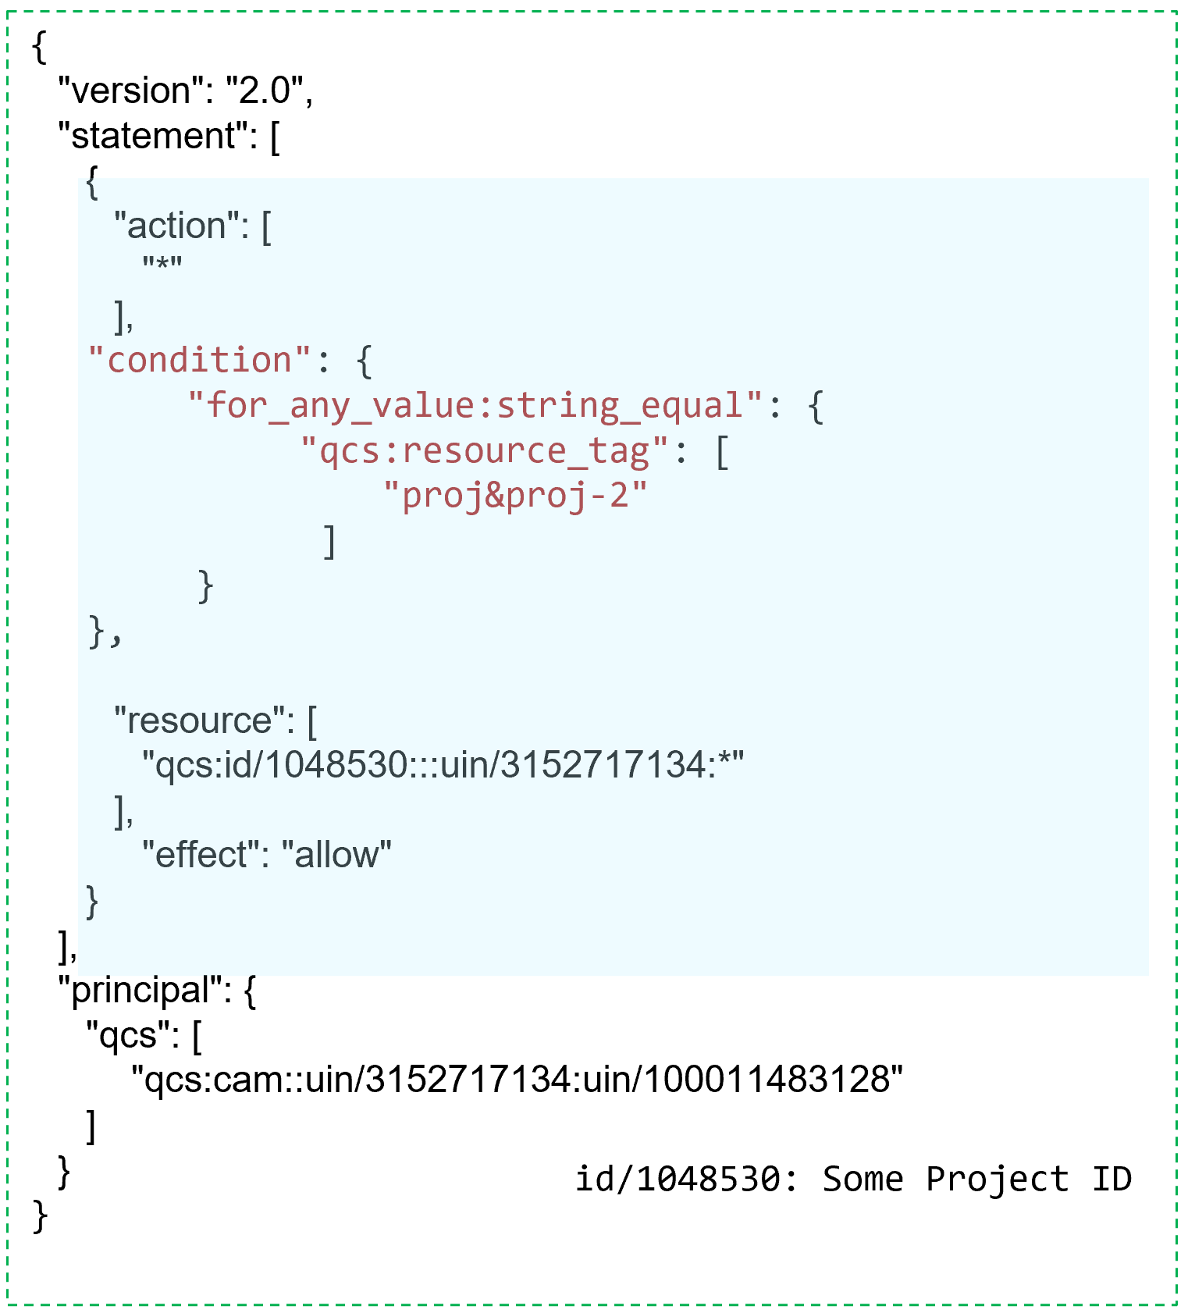
- Telcomsel can customize your policies to make fine-grained permissions through 5 fields:
- Effect: Allow/Deny
- Service: Select Service (e.g. Select TencentDB for MySQL)
- Action: Select actions on TencentDB for MySQL
- Resource: The default value is All resources (*).
- Condition: like Source IP/Time. Detail refers to Condition Keys and Condition Operators | Tencent Cloud
- CAM can work with resources tags. If you have purchased multiple types of Tencent Cloud resources which are grouped and managed by tag, you can grant employees of different teams/roles permissions to use corresponding APIs by tag on an as-needed basis. Refer to: Authorizing Certain Operations by Tag | Tencent Cloud
- User group also can be used to batch authorize users and set message subscriptions for better management of users and their permissions. User group is a set of multiple users (sub-accounts) with the same function. The root account and sub-accounts with admin permissions can create different user groups based on business. Refer to: Creating User Group | Tencent Cloud

3.2. Billing by Tag
Tags used for bill splitting and cost analysis are called cost allocation tags, which is a collection of resource labels managed by users according to their own requirements. This function can help customers customize the management of statistical analysis dimensions, to better suit the various demands of customers for billing and cost analysis.
Cost allocation tags: Cost allocation tags for bill splitting is a way for customers to set tags for Tencent Cloud resources, and the bill matches the corresponding tag information of the resources according to the resources and reflects the tag information in the bill, so that the customer can ultimately analyze the cost information statistically based on the tag information in the bill.
Setup cost allocation tags steps:
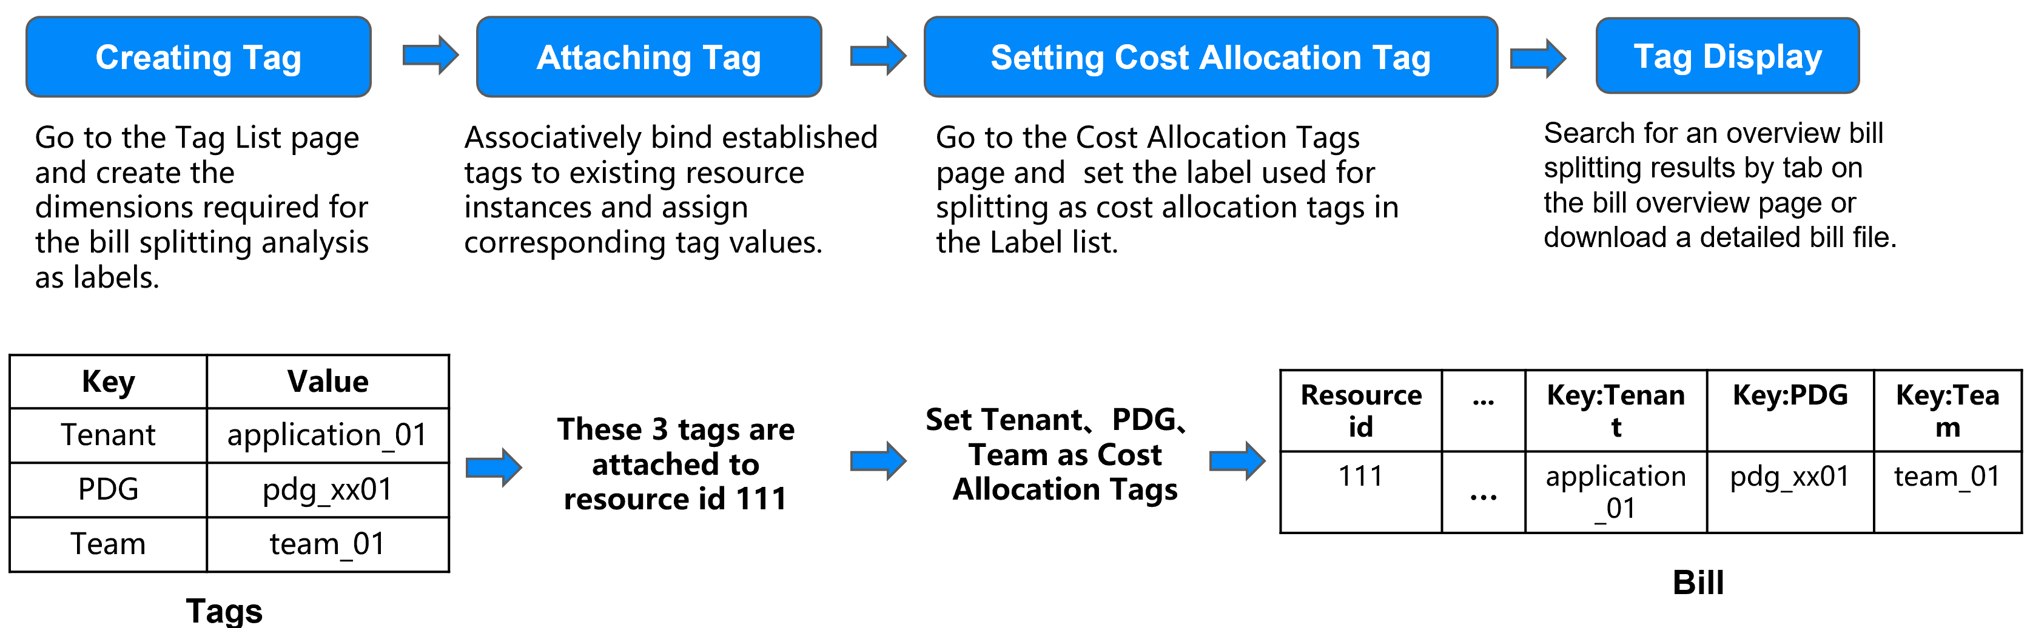
- Creating Tags and Attaching to Cloud resources
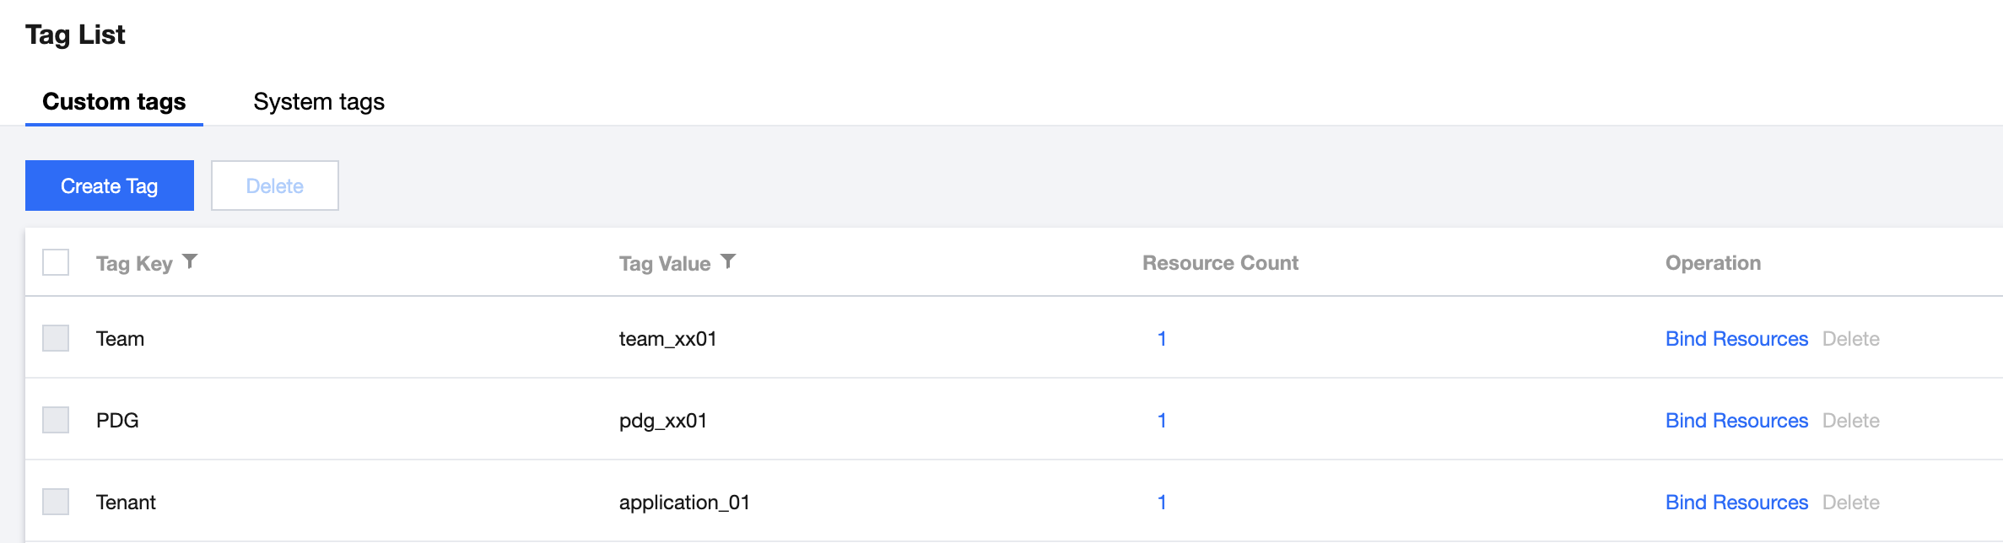
- Setting These tags as ‘Cost Allocation Tags’
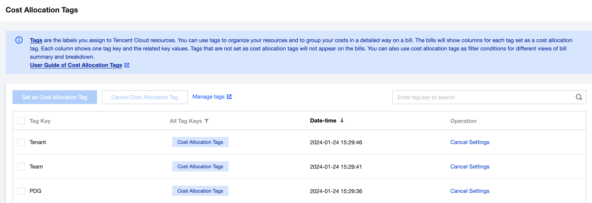
- Billing by Tags
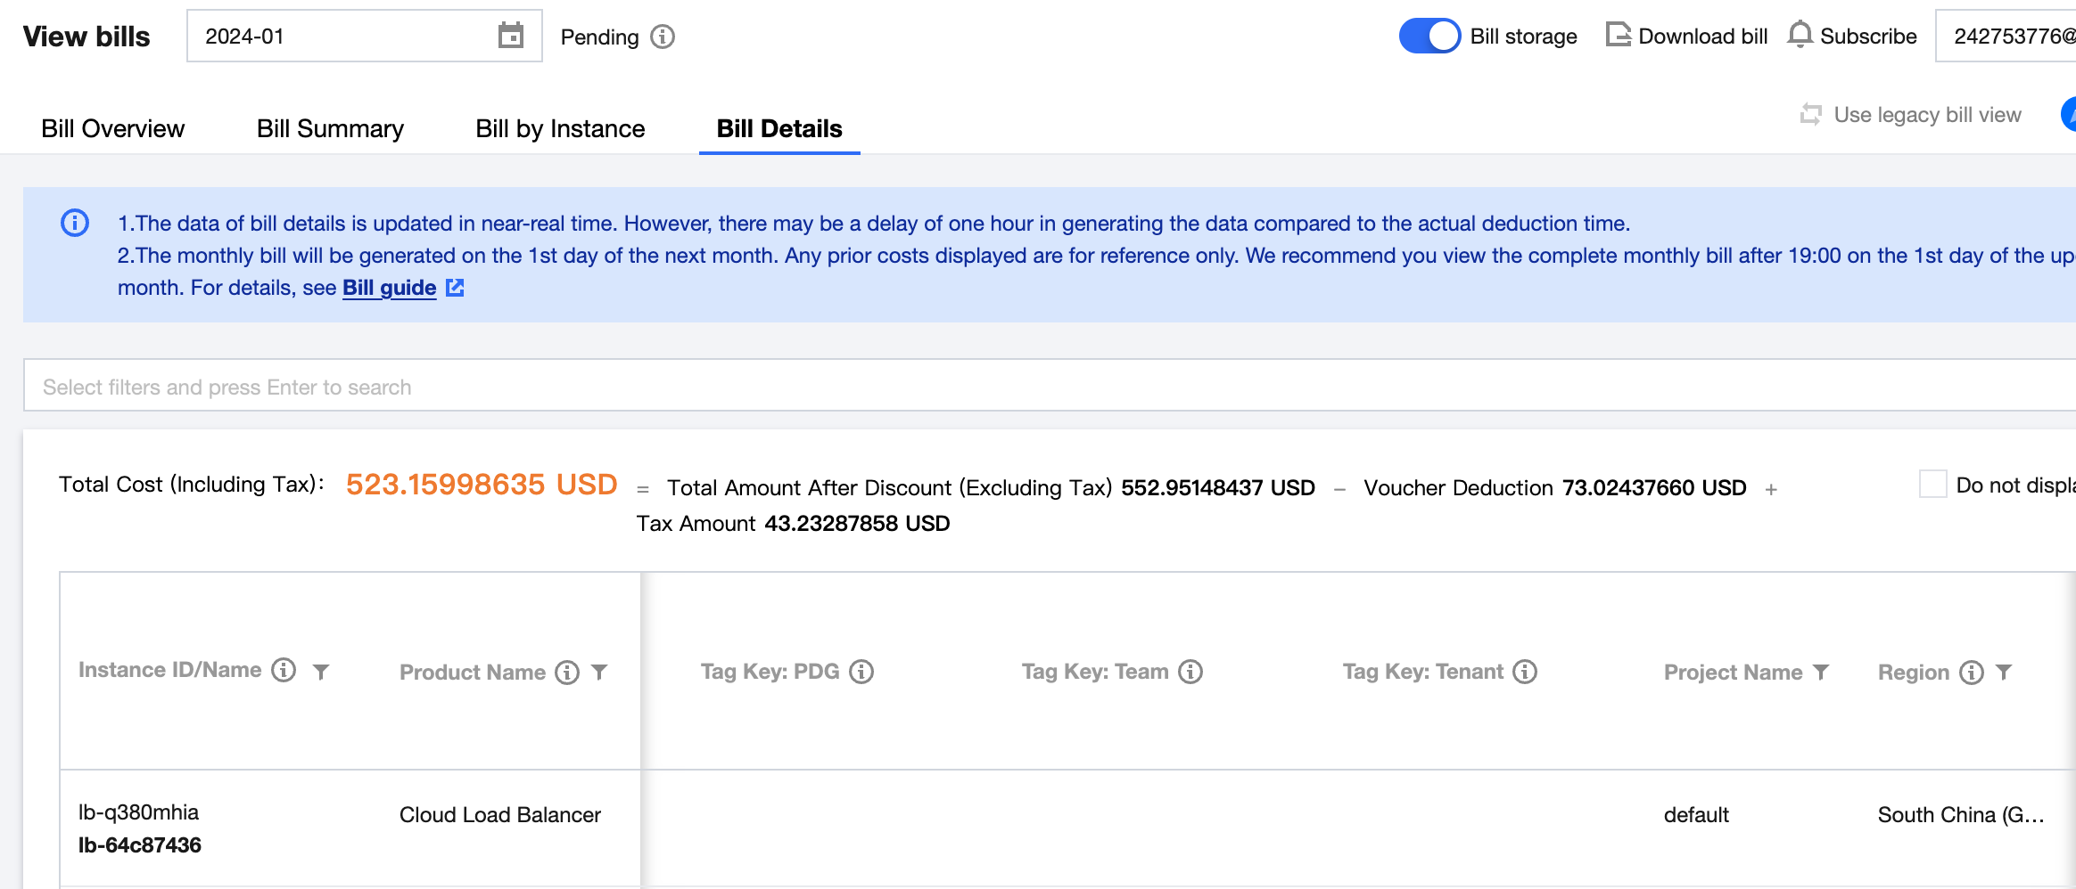
- Each cost allocation tag is a column in bills, and the values of a tag are displayed in the corresponding rows of the resources they are attached to.
- These billing can be saved into Tencent Object Storage (COS) and analysis by Big Data platform.

4. Capabilities/Limitations
- Tags overview: Overview | Tencent Cloud
- Tags limitations: Use Limits | Tencent Cloud
- CAM overview: Overview | Tencent Cloud
- CAM Security best practice: Security Best Practice | Tencent Cloud
- CAM on Tag: Authorizing Certain Operations by Tag | Tencent Cloud
- CAM limits: Use Limits | Tencent Cloud
- Integrated Enterprise IdP: Configure OIDC In the Enterprise IdP | Tencent Cloud(Detail demo can refer to Security Demo:SC004)
- Billing allocation by tags: Cost Allocation Tags | Tencent Cloud
- Billing under CAM: Granting Billing-related CAM Access | Tencent Cloud

Tencent Cloud Organization
In case Telcomsel requires multiple Tencent Cloud Accounts to make fully isolation between your entities and want to do categorized account management, Tencent Cloud Organization service can be used for this request.
Tencent Cloud Organization (TCO) is an account management service that enables you to centrally manage multiple Tencent Cloud accounts by integrating them with an organization you created. It provides features that lets you view bills and manage accounts to meet your budgeting, security, and compliance needs.
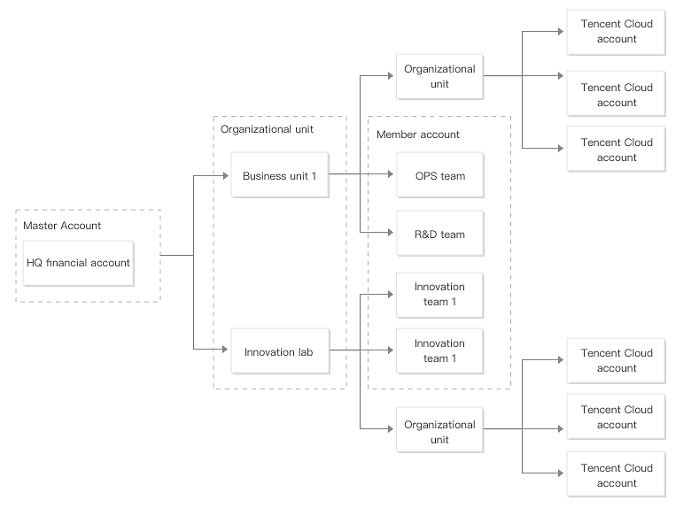
Tencent Cloud Organization provide functions as below:
Name | Feature
Organization settings | Creating an organization
Organization settings | Viewing the organization information
Organization settings | Deleting an organization
Organization settings | Viewing the invitation information
Organization settings | Accepting or rejecting an invitation
Organization settings | Leaving an organization
Department management | Creating a department
Department management | Modifying the department information
Department management | Deleting a department
Department management | Moving a member
Member account management | Viewing the member list and basic member information
Member account management | Removing a member
Member account management | Inviting a member
Member account management | Canceling a member invitation
Member account management | Granting a member the account access
Service control policy | Service control policy overview
Service control policy | Enabling a service control policy
Service control policy | Creating a custom service control policy
Service control policy | Viewing service control policy details
Service control policy | Modifying a custom service control policy
Service control policy | Deleting a custom service control policy
Service control policy | Binding a custom service control policy
Service control policy | Unbinding a custom service control policy
Service control policy | Disabling a service control policy
Member audit | Auditing member logs

Detail documents please refer to: Organization Overview | Tencent Cloud

Tencent Cloud Control Center
Tencent Control Center(LandingZone) gives enterprises a top-level solution for centrally managing numerous accounts in their Tencent Cloud environment. By configuring a landing zone, enterprise administrators can quickly build a safe and compliant cloud environment in which account permissions, finance, security, and compliance can be easily managed based on best practices.
Follow Control Center’s process, Telcomsel can systematically organize Tencent Cloud's various management and control services (like CAM/Tags/etc), complete your organization/ account/ user/ resource management planning.
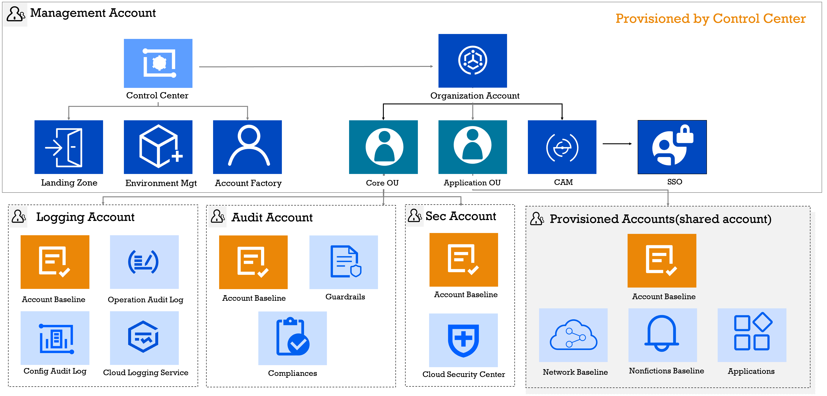
Control Center Capabilities:
- Central Management of Enterprise Accounts: enables a clear division of permissions and enables enterprises to rapidly setup necessary accounts, helping them quickly design a multi-account environment.
- Finance Management: provides two payment modes and several financial permissions for finance personnel to manage multiple cloud accounts in a unified way.
- Permissions Management: Control Center addresses these issues by integrating the enterprise admin account and internal accounts. Employees can log in to the Tencent Cloud console with single sign-on (SSO). The admin account can allocate Cloud Access Management (CAM) roles with specific permissions to sub-users, and sub-users can view the roles allocated to them.
- Log Collection and Auditing: With simple configurations, administrators can continuously collect audit logs from numerous accounts. A multi-account log management system that covers log generation, collection, retention, analysis, and alerting together with other Tencent Cloud products such as Tencent Cloud Organization, CloudAudit, and CLS.

For detail introduction refer to:
Feature | Description | Documentation
Landing Zone | A top-level framework for enterprise cloud migration. Landing zones enable enterprises to rapidly establish a cloud environment aligned with best practices. | Landing Zone
Baselines | Add and manage baselines for permissions, network, security, and finance and apply them to accounts to improve your delivery efficiency. | Baselines
Accounts | Rapidly configure multiple accounts to reduce delivery costs. | Accounts
Finance | View the organization’s financial structure and consolidated financial data for financial analysis of cloud accounts. | Finance
Security rules | View and configure security rules to ensure security in a multi-account environment. | Security Rules
Compliance audit | Track the destinations of config logs and CloudAudit logs. | Compliance Audit

More introduction refer to Control Center overview: Overview | Tencent Cloud

